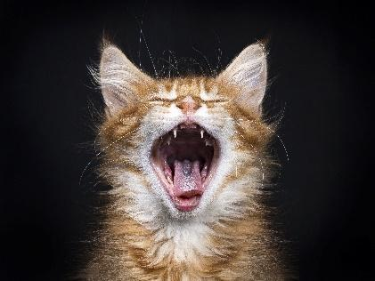
Cats needed for one-time saliva swab!

NC State College of Veterinary Medicine is looking for cats to participate in a one-time, 15 second oral swab. In return, you will get a $50 electronic gift card!

PARTICIPATION
- Owners must come to NCSU College of Veterinary Medicine one time. The swab can be collected from the car with the cat in their carrier.
- Cats need to have a diagnosis of one of the following: osteoarthritis, chronic kidney disease, IBD, GI Lymphoma, or be a healthy control.
- Cats that have not been treated with antibiotics, antivirals, antifungals or probiotics within a month of sample collection

INCLUSION CRITERIA
- Current exam within the last 6 months required to confirm diagnosis.
- Osteoarthritis: documented diagnosis by veterinarian. Preferably with radiographic evidence.
- Chronic kidney disease: any stage accepted, but they cannot have any other major systemic disease.
- IBD & GI Lymphoma: the diagnosis must be confirmed with biopsies and they need to be Felv/FIV negative.

For more information, contact the Clinical Studies Core:
Katie Richmond: 919-513-6453
cvmclinicalstudies@ncsu.edu

