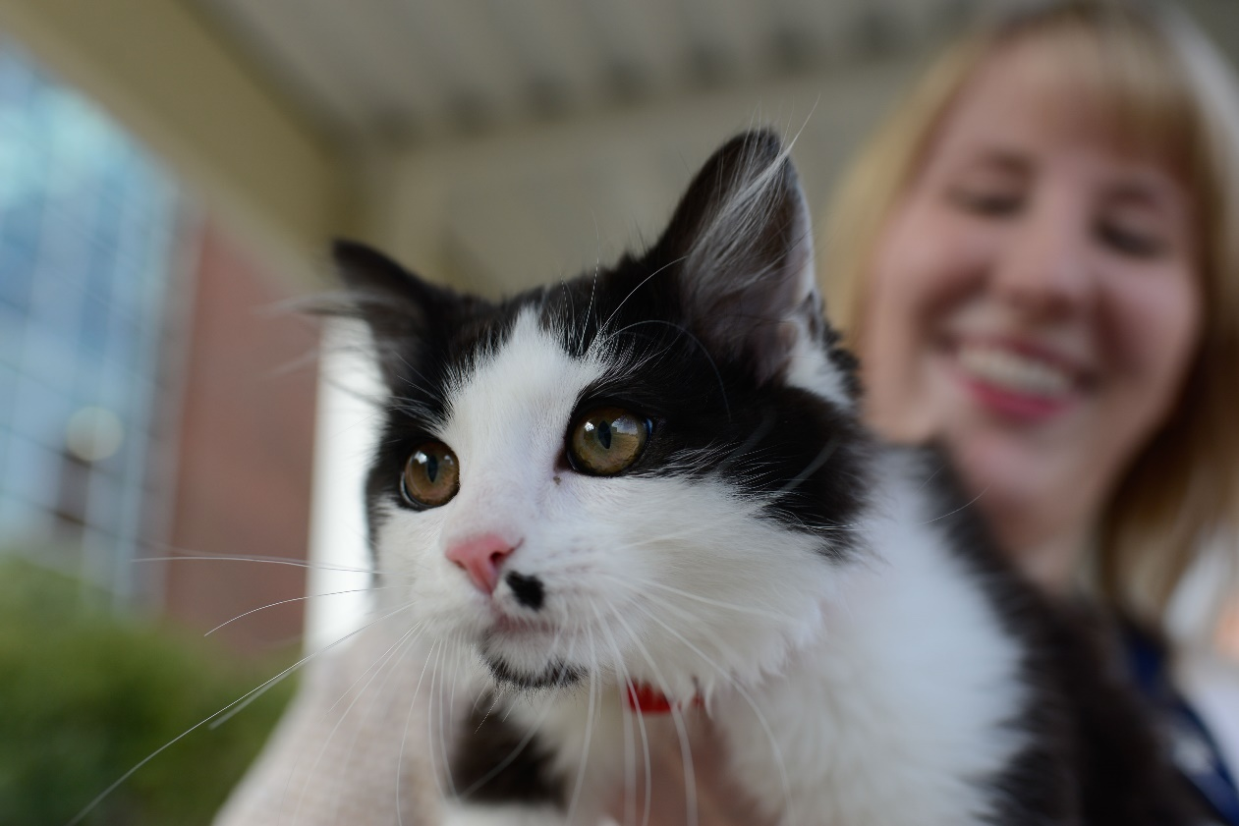

**Now Enrolling**

**Cats**

**with Anemia and**

**Chronic Kidney Disease**

NC State Nephrology-Urology is enrolling cats with anemia and chronic kidney disease (CKD) to explore the need for iron supplementation in conjunction with Varenzin CA-1® treatment.

PARTICIPATION:

* Each cat will be seen for 4 study visits after enrollment into the study. These visits will take place over a 9 week period.
* At study enrollment each cat will have the following testing performed: Complete blood cell count, blood chemistry panel, total T4, urinalysis, and blood pressure measurement
* After confirmation of enrollment, your cat will receive Varenzin CA-1® orally once per day
* At following visits (every 1-4 weeks), a complete blood count or PCV/TP and blood pressure will be performed.

ELIGIBILITY:

* Cats diagnosed with stable IRIS stage II -IV CKD (serum creatinine > 1.6 mg/dL)
* Anemia, defined as PCV 20-28%
* Criteria that exclude participation:
  + Cats with unstable CKD, acute kidney injury or cat with a SUB device
  + Cats receiving immunosuppressive medications at the time of enrolment: chlorambucil, corticosteroids, etc.
  + A logo with text and silhouettes of people

    Description automatically generatedA qr code with black squares

    AI-generated content may be incorrect.Cats with significant comorbidities including unregulated diabetes mellitus, unregulated hyperthyroidism, neoplasia, urinary tract infections, pyelonephritis, etc.

**For additional information contact the Harris Lab:**

**HarrisLab-ClinicalTrials@ncsu.edu**